December 6, 2020

Dr. Jenahvive Morgan  
College of Engineering  
Michigan State University  
219 Wilson Road  
East Lansing, MI 48825

Dear Dr. Morgan,

Attached is a copy of Section 15, Team 5’s Project #2 Checkpoint Report for EGR 100, Fall 2020.

This report describes a design modification to a GE wind turbine gearbox in order to prevent water ingress from corroding the machinery inside. The report includes the design prototype along with the methods and calculations conducted throughout the process.

The design is a device which will filter the air within the gearbox and remove water vapor and recirculate the dry air back into the gearbox.

I hope this report meets your requirements, and any questions will gladly be addressed by email.

Sincerely,

Kritika Saini, Craig Stebbing, Aman Todi, Vedi Patel

**INTRODUCTION**

The project was aimed at improving the design of Wind Turbine Generators (WTG). The current design of WTGs utilizes a gearbox to convert the massive torques and low speeds into mechanical power that can be fed to the electrical generator. Since WTGs are required to operate through difficult environments, the WTG gearbox is susceptible to water ingress which leads to the corrosion of delicate machinery inside the gearbox. This can cause a gearbox failure leading to huge repair costs. Professor Robert J K Wood, a researcher at the University of Southampton, emphasizes in his work that unexpected costs related to maintenance and repair undermine the capability of wind turbines to produce reliable energy. [1]

Another research article by O. El-Saeed notes that despite any thorough and detailed designing, the likelihood of gear corrosion remains very high and common. [2]. Therefore, the purpose of this undertaking was to design a system to remove water (liquid as well as vapor) from within the gearbox in order to prevent or decrease the probability of corrosion of gearbox machinery.

**METHODS**

Many initial ideas were not feasible or would not give the desired results. For instance, a sealant of some sort in order to prevent corrosion would wear away quickly due to the intense pressure between the gears. A vacuum technology could interfere with the lubricating oil which flows between the machinery. The design also needed to respect the various constraints of the project such as cost, operating temperature, size and the time gap between maintenances. A design was finally approved after it met the criteria of the project. The design consisted of a dehumidifier created using a Peltier device based on the principles of the Peltier effect. It was further optimized to improve cost and efficiency.

The Peltier effect is when heat is transferred between two electrical junctions, with an applied voltage to create an electric current. The Peltier device, based on this effect, creates a temperature difference within the system. To sum up Dr. T.M. Tritt’s explanation, a Peltier device uses an electrical current to create a temperature gradient which will create a colder side which absorbs the heat, and a hotter side which rejects the absorbed heat at the sink [3]. But this design uses a Peltier device with two heat sinks instead of one. The heat sink on the colder side condenses damp air while the heat sink on the hotter side dissipates heat along with dry air, maintaining the balance of the system. Figure 1 below shows a prototype designed using Autodesk Fusion.

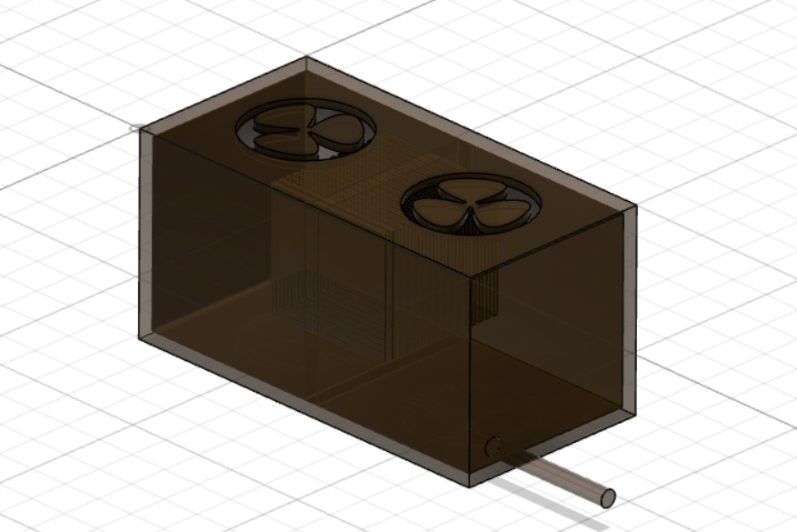

Figure 1: Initial prototype design for the dehumidifier

The design consists of two fans; one which sucks in air and expose it to the cold side (heat sink) of the Peltier device, and the other which releases the hot dry air from the other side. There is a gap in the wall supporting the two heat sinks which allows air to flow from the colder side to the hotter side. Once the water condenses within the dehumidifier, it will drop into a tray below and be rejected through a tube leading it outside of the wind turbine generator. The shell of the dehumidifier is recommended to be made from Carbon-steel. This is suggested after analyzing the costs of Carbon-steel and Stainless-steel keeping the durability requirements of the shell in mind given that it comes in direct contact with water. Below Figure 2 shows the prototype design attached to a hypothetical gearbox in order to better understand the intended orientation.

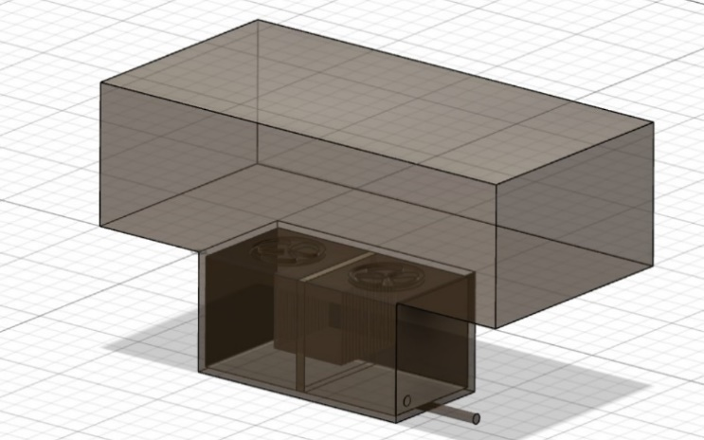

Figure 2: Prototype attached to gearbox

The data was collected by researching prices for each desired material and how much would be required to create the design. The heat sinks would be created using aluminum, and fans with polypropylene. The Peltier device would be purchased from an outside source and its cost was implemented into the total estimation as well. The outer-shell's material was finalized after analyzing its effect on the total cost. The shell’s thickness was finalized at 1 cm. The volume and mass of the material was found using the inner and outer dimensions of the shell according to equations 1 and 2. The values are displayed in table 1. The cost of each part was then combined to create and estimated total price.

$Volume=\left(outer length*outer width*outer height\right)-\left(inner length*inner width*inner height\right)$ (1)

$mass=volume×density$ (2)

Table 1: Shell dimensions and volume of material used



The dimensions were then changed to calculate the total cost of a variety of sizes; however, the same ratio among the sizes of each part was used. Table 2 displays the ratio and multiplication factor used for the outer shell of the design.

Table 2: Dimensions of outer shell and the multiplication factor



The ratio between the length, breadth and width of the shell's outer is a constant - 2:1:1. As the dimensions of the design increase, the design is assumed to follow this ratio. Establishing the ratio as a standard enables the use of a single variable obtained by dividing the dimensions by the ratio called the 'Multiplication Factor' to increase or decrease the size of the design in a uniform way. It also provides a way to graph a relationship between the dimensions of the design and the total cost of the project.

**RESULTS**

The design of the Peltier device has been explained above, and the attachment of the Peltier device to the gearbox has been finalized by keeping the most efficient orientation in mind. If the dehumidifier were to be in the gearbox, it would get very clustered and if it were to in the breather, the entire design of the pre-existing gear box would have to be changed. Keeping that in mind, the Peltier device’s location is horizontally next to the gearbox, making the circuit of air efficient and easy to modify.

The prices for each component of the design were calculated using different methods. For the shell, the required mass was multiplied with the current rate of material (Carbon-steel and Stainless steel) in USD/kg to get the cost. The volumes of the heat sinks were obtained by calculating it manually for the first model and then using the ratios between consecutive volumes of the inner spaces in the four models to get the volume for the other three models. The mass of aluminum required was obtained by multiplying the volumes with density of aluminum (table 3) and the cost was obtained by multiplying the mass by rate of aluminum (USD/kg).

Table 3: Calculation of volume and mass of material required for heat sinks



The cost of the fans and the Peltier Device were manually calculated by using their standard prices in the industry. While these may be off from their exact values, they serve as good estimates for the purpose of the design. The individual cost of each component is displayed below in table 4.

Table 4: Individual costs of components





The calculations showed that the cost of Carbon-steel for the shell was significantly less than that of Stainless-steel. However, this difference in price was somewhat undermined by the prices of other components like heat sinks and the Peltier device. The total costs of the models in each case are shown below along with the Multiplication Factor in table 5. As discussed earlier, the Multiplication Factor can be key to determining the total cost of a model using the dimensions and the standard ratio between them which is 2:1:1.

Table 5: Individual costs of components



The graph below (figure 3) demonstrates the relationship between the Multiplication Factor and the total cost of components in two scenarios: (i) using Carbon-steel for shell and (ii) using Stainless-steel for shell.

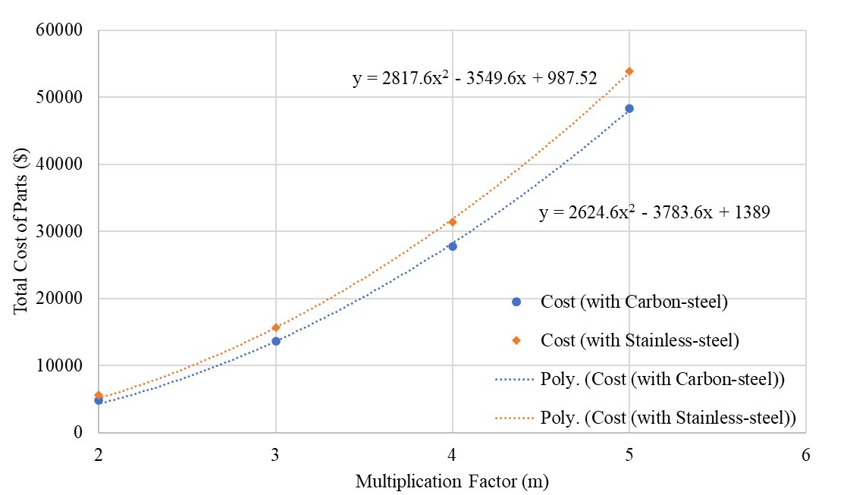

Figure 3: Change in total cost with respect to multiplication factor

As can be seen in the graph, the total cost of the components has an exponential relationship within the Multiplication Factor. The cost difference between the two materials increases as the multiplication factor increases. This demonstrates that the larger the desired size, the more beneficial it will be to use carbon-steel over stainless-steel for the outer shell of the design. The relationship between multiplication factor and the cost is quantized into equations for both the materials which can be used to calculate the cost for any desired dimensions, provided they are following the established ratio rule.

**CONCLUSION**

The objective of this project was to facilitate the removal of water from wind turbine gearboxes to prevent corrosion, associated failure, and repair costs. A very important thing that was considered while coming up with some possible solutions was to not hinder the structure of the gearbox. Keeping that in mind, the addition of a dehumidifier to the gearbox was finalized. The dehumidifier works on the principles of the Peltier effect. There were other factors that had to be considered while finalizing the design like the dimensions and the material the dehumidifier had to be made of. Since definite dimensions of the gearbox were not provided, the exact dimensions of the dehumidifier could not be determined. To tackle this limitation, different dimensions of the dehumidifier’s shell were chosen keeping the ratio between all the parts the same. The shell’s material was finalized to be Carbon-steel due to cost efficiency. The heat sinks would be created using aluminum, and fans with polypropylene. The Peltier Device is to be purchased from an outside source. The total cost calculated for the final model is $4792.08 for the multiplication factor of 2 and $48303.61 for the multiplication factor of 5. Lastly, this dehumidifier is designed to be attached to the gearbox horizontally ensuring no drastic change in the pre-existing structure of the gearbox.

**REFERENCES**

1. Wood, R. "Tribology and corrosion aspects of wind turbines." *Wind Energy-Challenges for Materials, Mechanics and Surface Science* p.p. 60 (2009).
2. O. El-Saeed and G. Sroka and G. Blake. *Gear Corrosion During the Manufacturing Process.* Available: <https://www.geartechnology.com/articles/0909/Gear_Corrosion_During_the_Manufacturing_Process/> (Nov 11, 2020)
3. T.M. Tritt. [*Thermoelectric Materials: Principles, Structure, Properties, and Applications*](https://www.sciencedirect.com/science/article/pii/B0080431526018222)*.* Available: <https://www.sciencedirect.com/topics/chemistry/peltier-effect> (Nov 11, 2020)